**Week 5 Module 8.2 Assignment: JSON Practice**

Juan Macias Vasquez

Bellevue University

CSD325-H323 Advanced Python (2255-DD)

**Jack Lusby**

June 28th, 2025

Module 8.2 Assignment: JSON Practice

Results Document

Flow Chart

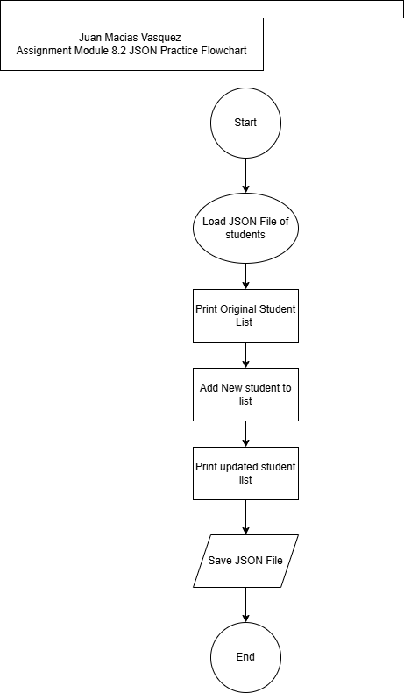

Made in Draw.io

Code of Python Program

# Juan Macias Vasquez

# Date 06/28/2025

# Module 8.2 JSON Practice

# student_nabager.py

import json

# Load the JSON data from the file

def load_students(filename):

with open(filename, 'r') as file:

return json.load(file)

# Print each student's details

def print_students(students):

for student in students:

print(f"{student['L_Name']}, {student['F_Name']} : ID = {student['Student_ID']} , Email = {student['Email']}")

# Append new student data to the list

def add_student(students, first_name, last_name, student_id, email):

new_student = {

"F_Name": first_name,

"L_Name": last_name,

"Student_ID": student_id,

"Email": email

}

students.append(new_student)

# Save the new updated student list to the JSON file

def save_students(filename, students):

with open(filename, 'w') as file:

json.dump(students, file, indent=4)

# === Main Program ===

filename = 'student.json'

# Load original data

students = load_students(filename)

# Display the original student list

print("\nOriginal Student List:")

print_students(students)

# Add my student info

add_student(students, "Juan", "Macias", 10000, "Student.email@example.com")

# Display the updated student list

print("\nUpdated Student List:")

print_students(students)

# Save the updated list back to the file

save_students(filename, students)

print("\nThe JSON file has been updated.")

Picture of Program Running

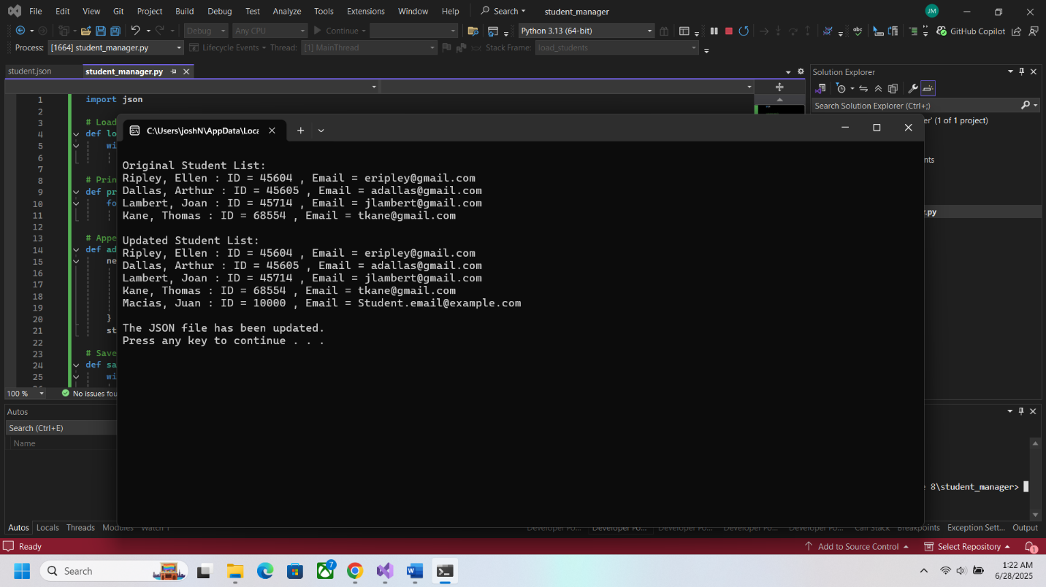

I did not get a pop-up message of the file changing but it did save the changes after checking in visual studio and when opening the text file after running it.

Picture of file after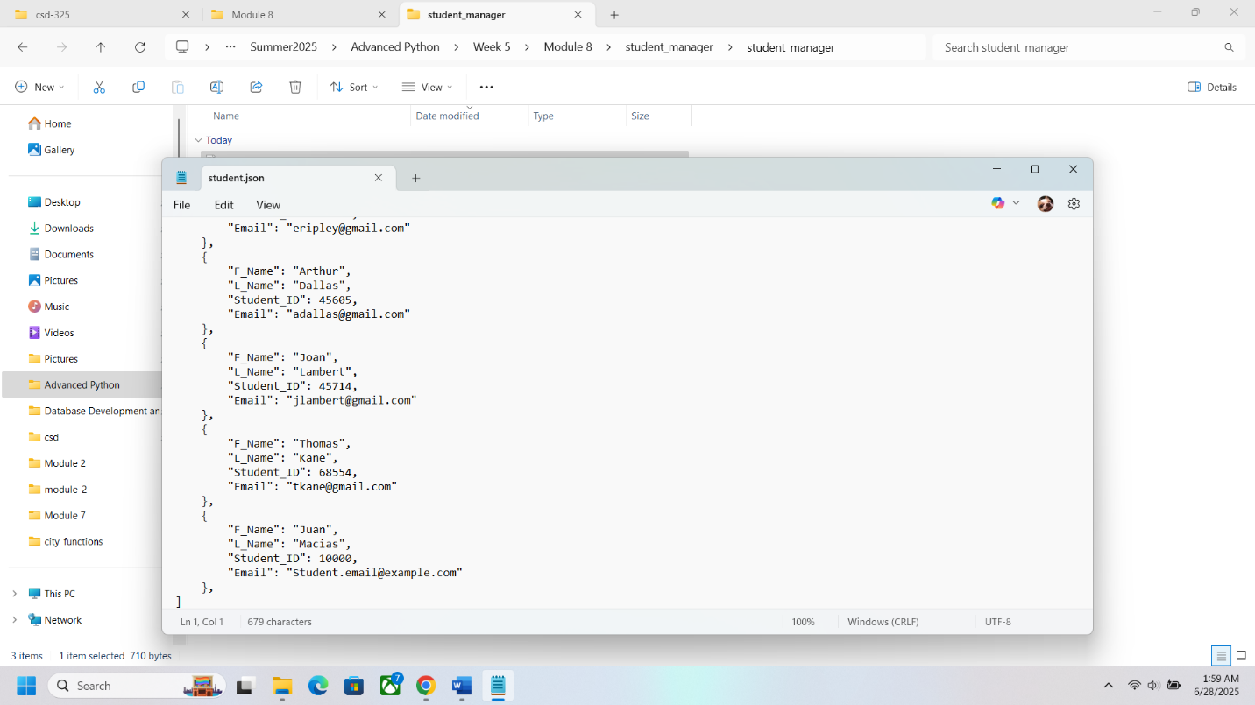

JSON file contents after running

[

{

"F_Name": "Ellen",

"L_Name": "Ripley",

"Student_ID": 45604,

"Email": "eripley@gmail.com"

},

{

"F_Name": "Arthur",

"L_Name": "Dallas",

"Student_ID": 45605,

"Email": "adallas@gmail.com"

},

{

"F_Name": "Joan",

"L_Name": "Lambert",

"Student_ID": 45714,

"Email": "jlambert@gmail.com"

},

{

"F_Name": "Thomas",

"L_Name": "Kane",

"Student_ID": 68554,

"Email": "tkane@gmail.com"

},

{

"F_Name": "Juan",

"L_Name": "Macias",

"Student_ID": 10000,

"Email": "Student.email@example.com"

}

]